Day 2: Timing Libraries, Synthesis Approaches, and Efficient Flip-Flop Coding
Welcome to Day 2 of the RTL Workshop. This day covers three crucial topics:
- Understanding the .lib timing library (sky130_fd_sc_hd__tt_025C_1v80.lib) used in open-source PDKs.
- Comparing hierarchical vs. flat synthesis methods.
- Exploring efficient coding styles for flip-flops in RTL design.
Contents
- Timing Libraries
  - SKY130 PDK Overview
  - Decoding tt_025C_1v80 in the SKY130 PDK
  - Opening and Exploring the .lib File
- Hierarchical vs. Flattened Synthesis
  - Hierarchical Synthesis
  - Flattened Synthesis
  - Key Differences
- Flip-Flop Coding Styles
  - Asynchronous Reset D Flip-Flop
  - Asynchronous Set D Flip-Flop
  - Synchronous Reset D Flip-Flop
- Simulation and Synthesis Workflow
  - Icarus Verilog Simulation
  - Synthesis with Yosys

Timing Libraries
SKY130 PDK Overview
The SKY130 PDK is an open-source Process Design Kit based on SkyWater Technology's 130nm CMOS technology. It provides essential models and libraries for integrated circuit (IC) design, including timing, power, and process variation information.
Decoding tt_025C_1v80 in the SKY130 PDK
- tt: Typical process corner.
- 025C: Represents a temperature of 25°C, relevant for temperature-dependent performance.
- 1v80: Indicates a core voltage of 1.8V.
This naming convention clarifies which process, voltage, and temperature conditions the library models.

Opening and Exploring the .lib File
To open the sky130_fd_sc_hd__tt_025C_1v80.lib file:
- Install a text editor:
sudo apt install gedit
- Open the file:
gedit sky130_fd_sc_hd__tt_025C_1v80.lib
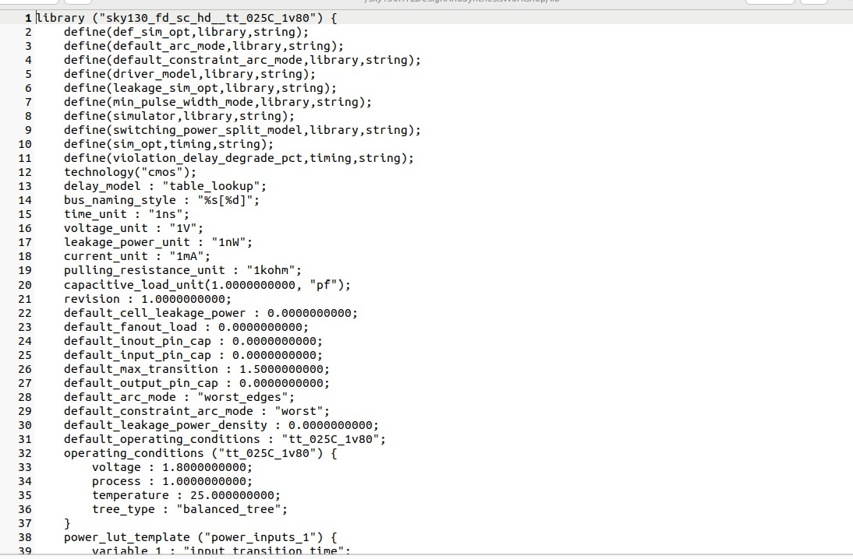

Hierarchical vs. Flattened Synthesis
Hierarchical Synthesis
- Definition: Retains the module hierarchy as defined in RTL, synthesizing modules separately.
- How it Works: Tools like Yosys process each module independently, using commands such as hierarchy to analyze and set up the design structure.
Advantages:
- Faster synthesis time for large designs.
- Improved debugging and analysis due to maintained module boundaries.
- Modular approach, aiding integration with other tools.
Disadvantages:
- Cross-module optimizations are limited.
- Reporting can require additional configuration.
Example: 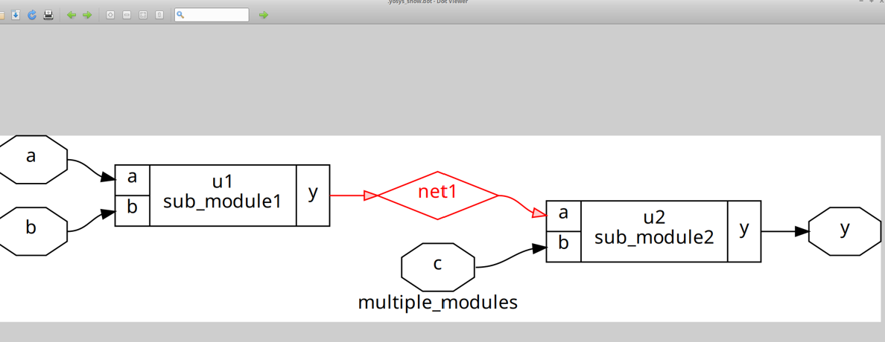
Flattened Synthesis
- Definition: Merges all modules into a single flat netlist, eliminating hierarchy.
- How it Works: The flatten command in Yosys collapses the hierarchy, allowing whole-design optimizations.
Advantages:
- Enables aggressive, cross-module optimizations.
- Results in a unified netlist, sometimes simplifying downstream processes.
Disadvantages:
- Longer runtime for large designs.
- Loss of hierarchy complicates debugging and reporting.
- Can increase memory usage and netlist complexity.
Example:
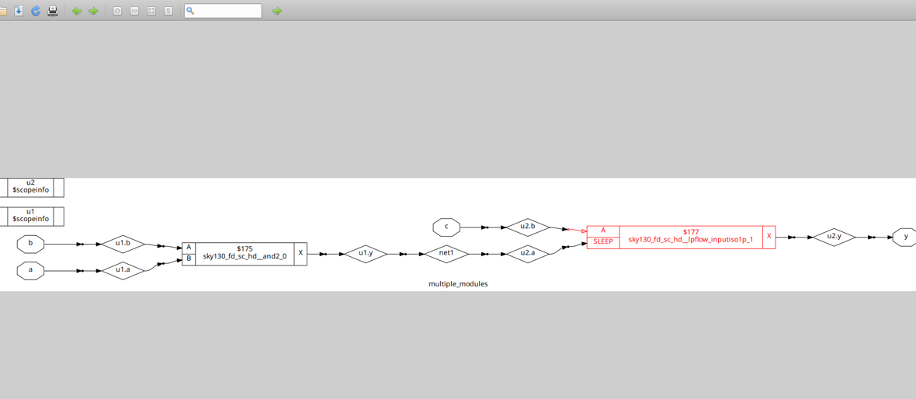
Important: Hierarchical synthesis maintains sub-modules in the design, while flattening produces a netlist from the ground up.

Key Differences
Aspect | Hierarchical Synthesis | Flattened Synthesis
Hierarchy | Preserved | Collapsed
Optimization Scope | Module-level only | Whole-design
Runtime | Faster for large designs | Slower for large designs
Debugging | Easier (traces to RTL) | Harder
Output Complexity | Modular structure | Single, complex netlist
Use Case | Modularity, analysis, reporting | Maximum optimization

Flip-Flop Coding Styles
Flip-flops are fundamental sequential elements in digital design, used to store binary data. Below are efficient coding styles for different reset/set behaviors.
Asynchronous Reset D Flip-Flop
module dff_asyncres (input clk, input async_reset, input d, output reg q);
always @ (posedge clk, posedge async_reset)
if (async_reset)
q <= 1'b0;
else
q <= d;
endmodule
- Asynchronous reset: Overrides clock, setting q to 0 immediately.
- Edge-triggered: Captures d on rising clock edge if reset is low.
Asynchronous Set D Flip-Flop
module dff_async_set (input clk, input async_set, input d, output reg q);
always @ (posedge clk, posedge async_set)
if (async_set)
q <= 1'b1;
else
q <= d;
endmodule
- Asynchronous set: Overrides clock, setting q to 1 immediately.
Synchronous Reset D Flip-Flop
module dff_syncres (input clk, input async_reset, input sync_reset, input d, output reg q);
always @ (posedge clk)
if (sync_reset)
q <= 1'b0;
else
q <= d;
endmodule
- Synchronous reset: Takes effect only on the clock edge.

Simulation and Synthesis Workflow
Icarus Verilog Simulation
- Compile:
iverilog dff_asyncres.v tb_dff_asyncres.v
- Run:
./a.out
- View Waveform:
gtkwave tb_dff_asyncres.vcd
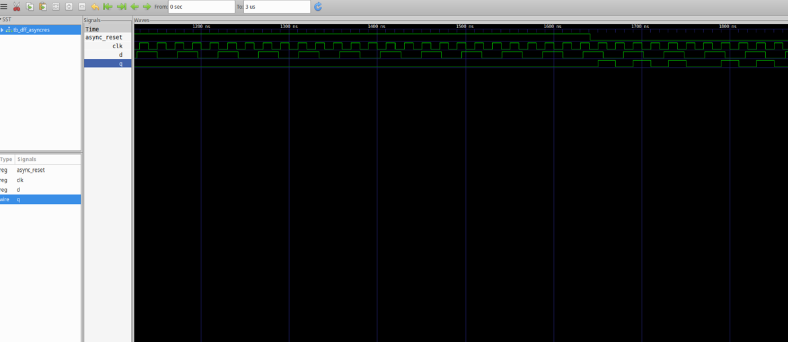
Synthesis with Yosys
- Start Yosys:
yosys
- Read Liberty library:
read_liberty -lib /address/to/your/sky130/file/sky130_fd_sc_hd__tt_025C_1v80.lib
- Read Verilog code:
read_verilog /path/to/dff_asyncres.v
- Synthesize:
synth -top dff_asyncres
- Map flip-flops:
dfflibmap -liberty /address/to/your/sky130/file/sky130_fd_sc_hd__tt_025C_1v80.lib
- Technology mapping:
abc -liberty /address/to/your/sky130/file/sky130_fd_sc_hd__tt_025C_1v80.lib
- Visualize the gate-level netlist:
show
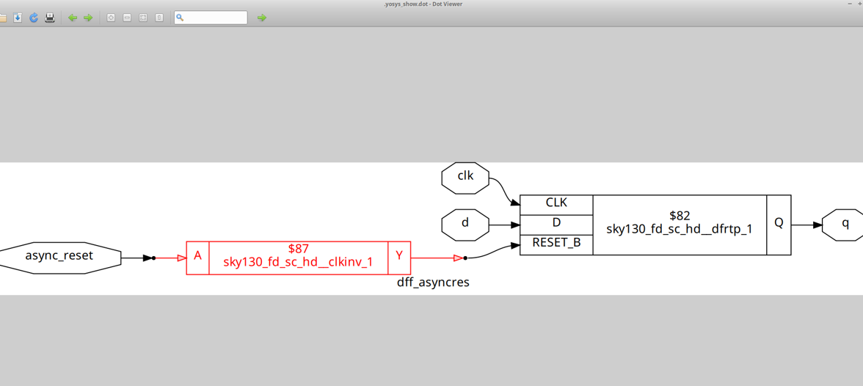

Summary
This overview provides you with practical insights into timing libraries, synthesis strategies, and reliable coding practices for flip-flops. Continue experimenting with these concepts to deepen your understanding of RTL design and synthesis.

